3. Data and Methods

3.1 Data Source and Data Cleaning
The empirical analysis is based on the PISA 2018 database. For sample selection, China Hong Kong and four Nordic countries (Finland, Denmark, Sweden, and Norway) were selected as comparative groups to represent the high-competition East Asian model and the high-welfare Nordic model, respectively. During the data cleaning process, cases with missing values for core variables (frequency of digital sports participation, scores in the three domains, ESCS, and gender) were excluded using listwise deletion. The final dataset constitutes a valid sample with a two-level nested structure (students nested within schools), providing a robust foundation for cross-national comparative analysis.

3.2 Variable Measurement and Standardization
To ensure model convergence and the comparability of regression coefficients, key variables were pre-processed prior to analysis.
Independent Variable: "Digital Sports Participation," derived from the PISA ICT questionnaire, was Z-score standardized (Mean=0, SD=1) before entering the model to eliminate dimensional differences.
Dependent Variables: The study employed the Plausible Values (PVs) for Mathematics, Science, and Reading provided by PISA to accurately estimate academic proficiency.
Control Variables: To isolate the net effects, we controlled for ESCS (Index of Economic, Social and Cultural Status), Gender, and ICT usage habits at the student level; and Student-Teacher Ratio, Teacher Shortage Index, and School ICT Resources at the school level.

3.3 Statistical Modeling
All statistical inferences were generated using Hierarchical Linear Modeling (HLM) to account for the nested data structure. Analyses were conducted using STATA/SPSS software, employing Restricted Maximum Likelihood (REML) estimation to minimize bias in variance components.

4. Results

4.1 Descriptive Statistics and Group Differences
First, means and standard deviations were calculated for continuous variables, and percentages for categorical variables. Independent sample t-tests and Chi-square tests were conducted to compare significant differences between the Hong Kong and Nordic groups, providing a data-driven basis for subsequent heterogeneity analyses.

Table 1: Descriptive Statistics by Region
 | Hong Kong |  | Nordic Countries
 | mean | sd | mean | sd
Math | 554.42 | 92.25 | 502.00 | 87.58
Reading | 527.33 | 97.90 | 501.77 | 101.95
Science | 519.38 | 85.24 | 495.26 | 97.61
Total | 0.00 | 0.94 | 0.00 | 0.94
Digital Sports | -0.00 | 1.00 | 0.00 | 1.00
Gender, 1=Male | 1.51 | 0.50 | 1.50 | 0.50
ESCS | -0.52 | 1.00 | 0.39 | 0.82
Academic ICT | 0.15 | 0.90 | 0.02 | 0.71
PE Classes | 2.00 | 0.85 | 1.98 | 0.89
Teacher ICT Training | 2.71 | 0.52 | 2.88 | 0.62
S-T Ratio | 12.67 | 4.36 | 11.90 | 2.58
Social Interaction | 0.11 | 0.87 | 0.03 | 0.80
Sense of Belonging | -0.40 | 0.66 | 0.15 | 1.05
Observations | 6037 |  | 24623

4.2 Main Effects and Non-linear Tests

To verify the non-linear impact of digital sports on academic performance, nested models were constructed. Based on a baseline model controlling for all covariates, we first tested the coefficient of the linear term for digital sports. Subsequently, the quadratic term ($Digital Sports^2$) was introduced. The final mixed-effects model equation is specified as follows:
$$Y_{ij}=γ_{00}+β_{1}({DigiSports}_{ij})+β_{2}({DigiSports}_{ij})^{2}+\sum_{k=1}^{K}{δ_{k}}X_{kij}+\sum_{m=1}^{M}{θ_{m}}W_{mj}+u_{0j}+ϵ_{ij}$$

Table 2: Linear Associations between Digital Sports and Academic Achievement
Mathematics |  |  |  | Reading |  |  | Science
 | HK | Nordic | HK |  | Nordic | HK |  | Nordic
Gender, 1=Male | 17.178***  (2.274) | 1.470  (1.342) | -11.713***  (2.399) |  | -33.171***  (1.586) | 12.186***  (2.220) |  | -5.889***  (1.497)
ESCS | 3.612** | 23.597*** | 2.522 |  | 24.743*** | 4.033** |  | 26.657***
 | (1.388) | (0.693) | (1.362) |  | (0.816) | (1.282) |  | (0.751)
PE Classes | -3.226** | -5.444*** | -3.827** |  | -8.552*** | -2.791* |  | -7.025***
 | (1.121) | (0.605) | (1.249) |  | (0.660) | (1.191) |  | (0.637)
Teacher ICT Training | -12.384  (8.064) | 4.534***  (1.299) | -6.147  (7.988) |  | 4.825**  (1.582) | -10.786  (6.698) |  | 2.867  (1.519)
Social ICT Perception | -10.860***  (1.354) | -4.503***  (0.776) | -13.083***  (1.314) |  | -6.597***  (0.882) | -10.030***  (1.225) |  | -4.322***  (0.854)
Digital Sports | -4.559***  (1.066) | -10.126***  (0.660) | -4.610***  (1.170) |  | -14.145***  (0.752) | -4.014***  (1.108) |  | -13.463***  (0.730)
 | 6037 | 24623 | 6037 |  | 24623 | 6037 |  | 24623
BIC | 586647.06 | 3043790.77 | 590962.04 |  | 3112431.94 | 579491.54 |  | 3091176.61
( χ2 value; *p<0.050, **p<0.010, ***p<0.001.)

4.3 Moderation Effect Analysis

To explore the mechanism of ICT literacy, we introduced an interaction term: Digital Sports × ICT Autonomy. This test aimed to determine whether ICT autonomy alters the slope of the impact (a buffering effect) or merely shifts the intercept (a compensatory effect), thereby clarifying the role of digital capital. The model formula is:
$$Y=β_{0}+β_{1}X+β_{2}M+β_{3}(X×M)+ϵ$$

Table 3: Interaction Effects of Digital Sports and ICT Attributes on Student Performance
Mathematics |  |  |  |  | Reading |  | Science
 |  | HK | Nordic | HK |  | Nordic | HK | Nordic
Digital Sports | -4.627*** |  | -10.179*** | -4.846*** |  | -14.181*** | -4.209*** | -13.494***
 | (1.071) |  | (0.663) | (1.171) |  | (0.757) | (1.107) | (0.736)
ICT Autonomy | 10.517*** |  | 6.307*** | 14.273*** |  | 6.696*** | 11.274*** | 7.281***
 | (1.269) |  | (0.774) | (1.223) |  | (0.864) | (1.167) | (0.865)
Digital Sports*  ICT Autonomy  ICT Interest | 0.464  (1.143) |  | -0.325  (0.546) | 0.195  (1.251) |  | -0.517  (0.624) | 0.490  (1.027) | -0.327  (0.567)
Digital Sports*  ICT Autonomy  ICT Interest | 3.627** |  | 4.858*** | 4.356*** |  | 8.372*** | 1.659 | 5.835***
 | (1.183) |  | (0.685) | (1.142) |  | (0.790) | (1.180) | (0.749)
Digital Sports*  ICT Interest | 0.521  (1.110) |  | 0.738  (0.538) | 2.133  (1.289) |  | 0.676  (0.597) | 1.680  (0.992) | 0.515  (0.547)
Observations | 6037 |  | 24623 | 6037 |  | 24623 | 6037 | 24623
( χ2 value; *p<0.050, **p<0.010, ***p<0.001.)

4.4 Non-linear Association Analysis
To verify whether a "threshold effect" and complex non-linear relationships exist between digital sports and academic performance, a quadratic term ($\text{DigitalSport}{\text{s}}^{\text{2}}$) was introduced into the baseline linear model.The model formula is specified as follows.
$$Y_{ij}=γ_{00}+β_{1}(DS_{ij})+β_{2}(DS_{ij}^{2})+\sum{C}ontrols+ϵ_{ij}$$
To visually interpret the differences in non-linear patterns across institutional contexts, predictive marginal effect plots were generated based on the regression coefficients from Table 4. Specifically, the predicted academic scores were calculated with Digital Sports frequency (Z-score) ranging from -2 SD to +2 SD.

Table4:Non-linear Effects of Digital Sports on Achievement
 | Total | Math | Reading | Science
Digital Sports | -0.318*** | -0.300*** | -0.313*** | -0.340***
 | (0.032) | (0.034) | (0.035) | (0.032)
Nordic *Digital Sports | 0.023 | 0.024 | 0.012 | 0.033
 | (0.034) | (0.036) | (0.038) | (0.035)
$$\text{DigitalSport}{\text{s}}^{\text{2}}$$ | 0.142*** | 0.132*** | 0.140*** | 0.154***
 | (0.015) | (0.017) | (0.017) | (0.016)
Nordic*$\text{DigitalSport}{\text{s}}^{\text{2}}$ | -0.066*** | -0.058*** | -0.065*** | -0.075***
 | (0.016) | (0.017) | (0.018) | (0.017)
Gender | -0.075*** | 0.064*** | -0.281*** | -0.007
 | (0.013) | (0.013) | (0.014) | (0.014)
ESCS | 0.232*** | 0.240*** | 0.214*** | 0.243***
 | (0.007) | (0.007) | (0.007) | (0.007)
Academic ICT | -0.060*** | -0.055*** | -0.067*** | -0.058***
 | (0.007) | (0.007) | (0.007) | (0.007)
PE Classes | -0.068*** | -0.059*** | -0.078*** | -0.067***
 | (0.006) | (0.006) | (0.006) | (0.006)
Teacher ICT Training | 0.012 | 0.016 | 0.024 | -0.001
 | (0.016) | (0.017) | (0.017) | (0.017)
S-T Ratio | 0.004 | 0.006 | 0.005 | 0.003
 | (0.015) | (0.016) | (0.017) | (0.014)
Social Interaction | -0.006 | -0.007 | -0.014* | 0.002
 | (0.007) | (0.007) | (0.007) | (0.007)
Sense of Belonging | 0.032*** | 0.029*** | 0.043*** | 0.023***
 | (0.006) | (0.006) | (0.006) | (0.006)
Observations | 30660 | 30660 | 30660 | 30660
BIC | 750552.25 | 802674.88 | 790833.32 | 793326.58
( χ2 value; *p<0.050, **p<0.010, ***p<0.001.)
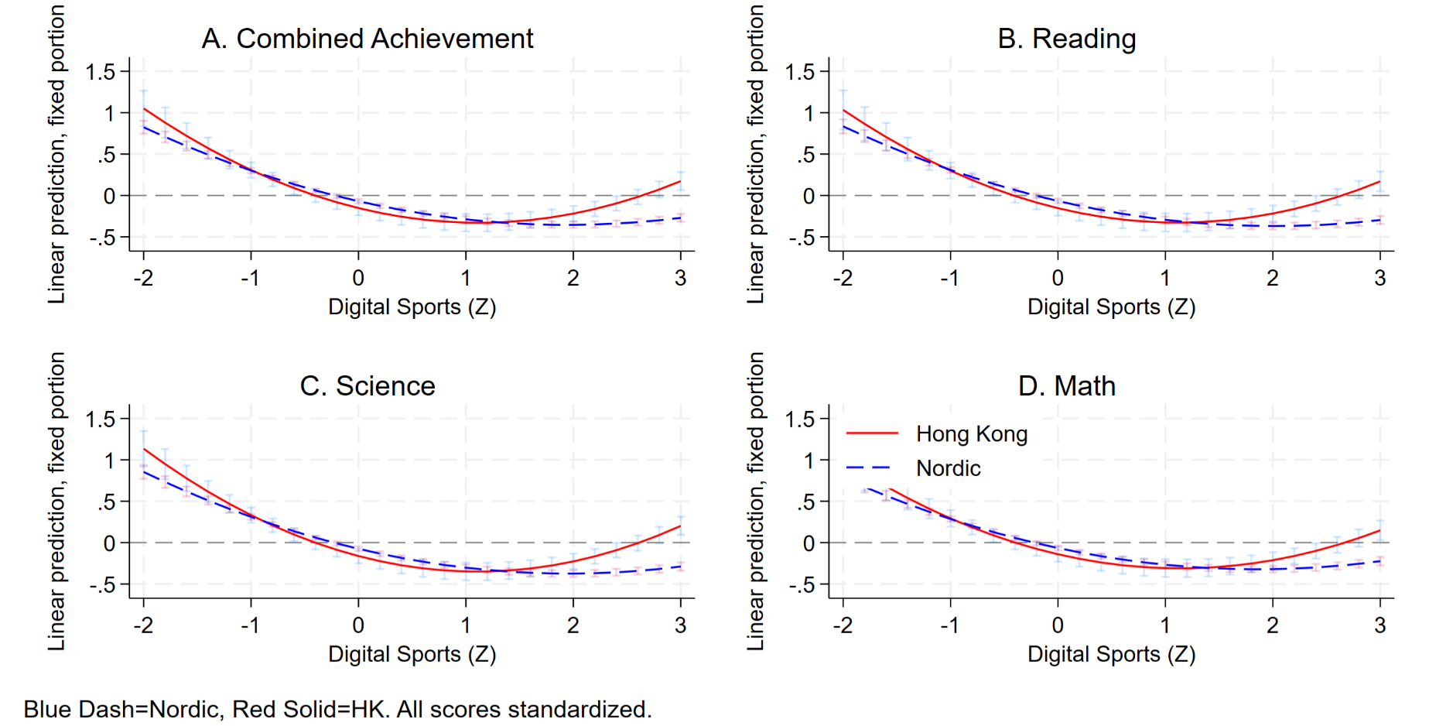

4.5 Robustness Checks and Validation
To ensure that the core finding—the U-shaped non-linear association between digital sports and academic performance—was not driven by functional form misspecification or extreme outliers, this study performed two rigorous robustness checks.
Check 1: Non-parametric Quintile Regression The frequency of digital sports participation was categorized into five quintiles (Groups 1–5), with "Group 1 (Low)" serving as the reference category. This allows for the observation of natural achievement trends across groups without imposing a parametric curve. As shown in Column (1) of the Robustness Table, compared to the reference group, students in the intermediate intensity groups (Group 3 and Group 4) exhibited the largest decline in scores (coefficients of -44.548 and -45.128, respectively). However, in the highest intensity group (Group 5), the negative coefficient rebounded to -40.874. This trend visually corroborates the non-linear "U-shaped" characteristic independent of curve assumptions.
Check 2: Trimmed Sample Regression Considering that extreme values (e.g., "heavy addiction" or "complete insulation") might skew the tail of the regression curve, we excluded outliers (reducing the sample size from 30,660 to 28,967) and re-ran the HLM model containing the quadratic term. As shown in Column (2), after removing extreme values, the coefficient of the quadratic term for digital sports remained high at 10.772 and statistically significant at the p < .001 level. This provides strong evidence that the U-shaped curve reflects the true structure of the data rather than a spurious correlation driven by outliers.

Table: Robustness Checks for Non-linear Associations
 | (1) | (2)
 | Model 1: Quintile Regression | Model 2: Trimmed Sample (|Z|<2.5)
 | b/se | b/se
pv1math
Nordic (Main Effect) | -59.208*** | -48.745***
 | (4.978) | (4.771)
Quintile 2 (Low-Mid) | -23.405***
 | (3.709)
Quintile 3 (Mid) | -44.548***
 | (8.994)
Quintile 4 (Mid-High) | -45.128***
 | (4.617)
Quintile 5 (High) | -40.874***
 | (2.062)
Nordic x Quintile 2 | -51.452***
 | (9.502)
Nordic x Quintile 3 | 6.728
 | (9.166)
Nordic x Quintile 4 | 11.271*
 | (4.682)
Gender (Male) | 3.989** | 5.680***
 | (1.223) | (1.206)
ESCS | 20.985*** | 21.612***
 | (0.641) | (0.660)
Academic ICT Use (Outside School) | -5.021*** | -4.806***
 | (0.610) | (0.617)
PE Classes Frequency | -5.269*** | -5.208***
 | (0.534) | (0.545)
Teacher ICT Training | 0.597 | 0.516
 | (1.565) | (1.540)
Student-Teacher Ratio | 0.566 | 0.867
 | (1.494) | (1.572)
Social ICT Perception | -0.870 | -0.832
 | (0.612) | (0.635)
Sense of Belonging | 2.883*** | 2.683***
 | (0.525) | (0.553)
Digital Sports (Linear) |  | -26.573***
 |  | (3.485)
Nordic x Digital Sports |  | 1.181
 |  | (3.717)
Digital Sports Sq. (Quadratic) |  | 10.772***
 |  | (2.607)
Nordic x Squared Term |  | 0.124
 |  | (2.926)
Constant | 576.543*** | 533.320***
 | (5.289) | (4.887)
lns1_1_1
Constant | 3.566*** | 3.569***
 | (0.028) | (0.029)
lnsig_e
Constant | 4.320*** | 4.322***
 | (0.005) | (0.005)
Observations | 30660 | 28967
BIC | 3630820.01 | 3433296.40

